Richard K. Campbell

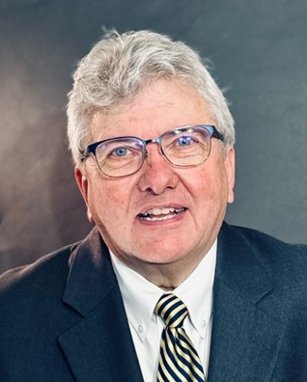
Vice President and Chief Financial Officer

- Master of Accounting Science, Specialization in Taxation (Northern Illinois University)
- Bachelor of Science, Accounting (University of Kentucky)

Richard Campbell serves as vice president and chief financial officer. He is a CPA licensed in Indiana. In addition, he is a chartered global management accountant (CGMA) and a certified fraud investigator (CFE). He has also held credentials as a certified internal auditor (CIA) and a certified information systems auditor (CISA).

Prior to coming to CBS, Richard served as vice president of corporate planning for Old Time Gospel Hour; vice president for financial services at Liberty University; treasurer and chief financial officer of Moody Bible Institute of Chicago; and senior vice president of finance for Prison Fellowship Ministries. He has held a number of other roles in nonprofits, including executive vice president of FamilyNet Broadcasting and director of internal audit at Indiana Wesleyan University, where he also worked in the Grants and Sponsored Research Office. He is the founder and principal of Kent Associates LLC, a CPA firm for nonprofits.

God led Richard and his wife Janine together in the University Class at Glendale Baptist Church in Bowling Green, Kentucky, where she talked him into working on a bus route. She has been talking him into things ever since. They have two children: Jeremiah (Lexington, Kentucky) and Rebekah (Chicago, Illinois). And a beagle, who enjoys playing briefly with any rabbits who happen into the backyard.

Richard and Janine are members of Twin Cities Bible Baptist Church in Gas City, Indiana.

